 

**MAULANA AZAD POLYTECHNIC, SOLAPUR.**

**MAHARASHTRA STATE BOARD OF TECHNICAL**

**EDUCATION, MUMBAI.**

**A MICRO PROJECT REPORT**

***Submitted by***

**Roll No Name of Students**

**1. Neha Dipak Sattarwale**

**2. Naushin chandsab diggi**

**3. Kashat Riyaz Ahmed fulari**

**4. Almas Hazratali walikar**

**5. Alfiya mazhar Shaikh**

***IN PARTIAL FULFILLMENT OF THE SIXTH SEMESTER***

***OF***

**DIPLOMA IN ENGINEERING AND TECHNOLOGY**

**IN**

**COMPUTER ENGINEERING**

***Under the guidance of***

***(……….)***

**A**

**Project Report**

**ON**

**Office Management System**

**Submitted in Partial fulfillment of the requirement, for the Diploma in Computer Technology at the**

**MAP Polytechnic Hotgi, Solapur**

**Submitted By:**

**Under the Guidance of**

**()**



**Department of Computer Engineering**

**MAULANA AZAD POLYTECHNIC,**

**SOLAPUR .**

**2021-2022**



**MAULANA AZAD POLYTECHNIC,**

**SOLAPUR.**

**CERTIFICATE**

**This is certify that the following students has successfully and satisfactorily completed and submitted the project.**

**Office Management System**

**In partial fulfillment of final year diploma course in Computer Science and Engineering prescribed by Maharashtra State Board of Technical Education for academic year 2021-2022.**

**Project Guide External**

**H.O.D Principal**

**ACKNOWLEDGEMENT**

It was highly eventful at the department of Computer Science & Engineering, MAP Polytechnic Hotgi, Solapur. We would sincerely like to thank our guide Mr/Ms(……..). giving us suggestions and taking a lot of interest in this project and whose advice and guidance helped us a lot. He has always been a source of inspiration for us right from feasibility of the Project.

We would like to thank Mr/Ms(……….) Head of Department and faculty of Computer Science and engineering for spending their valuable time for our Project, we are thankful for their guidance, encouragement and valuable suggestions which help us a lot enhancing our Project.

Lastly we are grateful to those people who directly and indirectly helped us during our Project work.

**ABSTRACT**

**Abstract of the Project Office Management System:**

Many articles in this first issue deal primarily with people issues and a knowledge of the technology is assumed. Meyer's article takes the reader on a quick tour of office information tools. As a foundation for discussion, it defines the scope, history, and current status of office automation. The office technology of today rests on a basis laid over decades by a number of management disciplines. Although there is a plenty of proof that office automation can quantitatively increase office output, it is the combination of qualitative and quantitative improvements that distinguishes today's office automation. The means to achieving this balance is a good office automation manager, able to coordinate various technologies and equally able to manage the people issues.

**CONTENTS**

PROJECT PEPORT 1

CERTIFICATE 2

ACKNOWLEDGEMENT 3

ABSTRACT 4

INDEX

**TOPIC Page No**

1.1Introduction……………………………………… …….

1System Requirement…………………………………...

Hardware Requirement:

Software requirements..

About The Microsoft Visual Studio……………… ……… ..

Data Flow Diagram…………………………………..……

Flow chart……………………………………………..

ER Diagram……………………………………….…

Features……………………………………

Software testing…………………………...

Coding………………………………….…

Output screen………………………………..

Conclusion …………………………………

**INTRODUCITON**

**The office automation system is an application that is designed to automate the processes that take place in the college office. There are many matters regarding the college that need to be maintained through the online method with the help of some application. The activities, student details and many matters like this can be better managed by the applications which are capable in doing this task. The admission details, students and faculty's information, feedback system performance of the students, reviews of the particular colleges, suggestions that can be given in some matters needed for improvement can all be dealt easily using the office automation system application.**

**The existing system involves a lot of human effort and it is difficult to maintain all the records manually through pen paper method. The office automation application must be having a strong back end system to store all the database of the college. This application will help in smooth running of the college management.**

**System Requirement**

Hardware Requirement:

* Processor : Pentium 4 or above.
* Hard disk : 50GB
* RAM : 512 MB or more

Software requirements:

* Operating System : Windows 7/Windows 10
* User Interface : Microsoft Visual Studio
* Database : Microsoft SQL

**About The Microsoft Visual Studio**

**Front End-**

|  |  |  |  |  |  |  |  |  |  |
| --- | --- | --- | --- | --- | --- | --- | --- | --- | --- |
| |  |  | | --- | --- | | **Paradigm** | **Structured, imperative, object-oriented, declarative, generic, reflective and event-driven** | | **Designed by** | **Microsoft** | | **Developer** | **Microsoft** | | **First appeared** | **2001** | |  |

**History of VB.NET :**

* VB.NET is a multi-paradigm programming language developed by Microsoft on the .NET framework. It was launched in 2002 as a successor to the Visual Basic language. This was the first version of VB.NET (VB.NET 7.0) and it relied on .NET version 1.0.
* In 2003, the second version of VB.NET, VB.NET 7.1, was released. This one relied on .NET version 1.1. This version came with a number of improvements including support for .NET Compact Framework and an improved reliability and performance of the .NET IDE. VB.NET 2003 was also made available in the academic edition of Visual Studio.NET and distributed to various scholars from different countries for free.
* In 2005, VB.NET 8.0 was released. The .NET core portion was dropped from its name so as to distinguish it from the classical Visual Basic language. This version was named Visual Basic 2005. This version came with many features since Microsoft wanted this language to be used for rapid application developers. They also wanted to make it different from C# language. Some of the features introduced by this version of VB.NET included partial classes, generics, nullable types, operator overloading, and unsigned integer support. This version also saw the introduction of the IsNot operator.
* In 2008, VB 9.0 was introduced. This was released together with .NET 3.5. Some of the features added to this release of VB.NET included anonymous types, true conditional operator, LINQ support, XML literals, Lambda expressions, extension methods, and type inference.
* In 2010, Microsoft released VB 2010 (code 10.0). They wanted to use a Dynamic Language Runtime for this release, but they opted for co-evolution strategy shared between VB.NET and C# to bring these languages closer to each other.
* In 2012, VB 2012 (code 11.0) was release together with .NET 4.5. Its features included call hierarchy, caller data, asynchronous programming with "await" and "async" statements and the "Global" keyword in the "namespace" statements.
* In 2015, VB 2015 (code 14.0) was released alongside Visual Studio 2015. The "?." operator was introduced to do inline null checks. A string interpolation feature was also introduced to help in formatting strings inline.
* In 2017, VB 2017 (code 15.0) was introduced alongside Visual Studio 2017. A better way of organizing source code in just a single action was introduced.

**VB.NET Features :**

VB.NET comes loaded with numerous features that have made it a popular programming language amongst programmers worldwide. These features include the following:

* VB.NET is not case sensitive like other languages such as C++ and Java.
* It is an object-oriented programming language. It treats everything as an object.
* Automatic code formatting, XML designer, improved object browser etc.
* Garbage collection is automated.
* Support for Boolean conditions for decision making.
* Simple multithreading, allowing your apps to deal with multiple tasks simultaneously.
* Simple generics.
* A standard library.
* **D ATA FLOW DIAGRAM:**

**Level 0 DFD:**

**Course Selection**

**Staff Selection**

**Add Staff Attendance**

Admin

**Add Exam**

**Add Student Section**

**Fees Section**

**Level 1 DFD:**

**Course Selection**

**Tbl_Course**

**Add Course**

**Tbl_Staff**

**Add Staff**

**Staff Selection**

**Staff Attendance**

**Staff Attendance**

**Tbl_Attendance**

**Add Exam**

**Exam Selection**

**Tbl_Exam**

**Add Student**

Tbl_ Student

**Student Selection**

**Fess**

**Fees Selection**

**Tbl_Fees**

Flow chart:

Admin:

**login**

**Dashbord**

**Course**

**Staff Selection**

**Exam Slection**

**Student Selection**

**Logout**

**ER DIAGRAM:**

**Password**

**User Name**

**Goto**

**Do**

**Login**

**Admin**

**Dept_name**

**Tutuion fees**

**Course**

**Fees**

Dashbord

**Donation Fees**

**Exam fees**

**ADD**

**Course**

**Do**

**Logout**

**Staff_name**

**Address**

**Mb_no**

**Staff**

**ADD**

**Work**

**Staff_ID**

**Select_staff**

**Date**

**ADD**

**Staff Attandance**

**Student Name**

**Address**

**Mobile_No**

**ADD**

**ADD**

**Student**

**Mb_No**

**Exam**

**Depertment**

**Dept name**

**Total marks**

**Subject name**

**Select Course**

**Selact course**

**Date of exam**

**Passing marks**

**Payed fess**

**Pending fess**

**Select Student**

**Total fess**

**Fees**

**ADD**

**View**

**Receipt**

**Features of Office Automation System:-**

**Attendance:**-

This module requires to enter the user id of the staffs and the students in order to

**Get the attendance :-**

Attendance view. Through this module the yearly or monthly attendance can be viewed.

**Course:-**

This module will provide the course details of the user.

**Department entry:-**

The department details can be manipulated through this module

• **Designation:-**

The designation details of the staffs can be manipulated through this module Donation This module will help in manipulating the donation details that have been given by the students held, pass marks, marks

**• Exam details:-**

. The details like subject name, date when the examobtained can be manipulated through this module, Fees details: This module will give the fees details

**Fees payment**:-

This module will provide the details of whether the fee payment have

**SCOPE**

The purpose of the Project Office Automation System (OAS) is to construct an application that can simplify operations in the college office. Using this, it is possible to maintain a database of college records, such as information about students enrolled in different classes, employee information in different departments, staff and non-staff descriptions, etc. The transaction containing payments and wages is also held Receipts of fees are provided for students Reports are preserved for future use. The search engine is used to search for the necessary details

Use of Office automation system

The purpose of this project is to simplify the work of the office. The existing procedure in the workplace is a manual system that requires a paper sheet. It is very difficult to keep track of all the information in such a system The purpose of our project is to develop an application that will automate processes in a college office.

**Software Testing**

**The purpose of system is to considered all the likely variation to which it will be suggested and push system to limits.**

**The process focuses on the logic intervals of these**

**Software ensuring that all the statements have been tested and on functional interval is conducting test to uncover error and ensure that defined input will produce actual result that agree with the required result program level testing, modules level testing integrated and carried out.**

**There are major types of testing:**

**WHITE BOX TESTING**

**BLACK BOX TESTING**

**WHITE BOX TESTING:**

**White box something called ”Glass Box Testing” is a test case design use to control structure of the procedural design to drive test cases.**

**Using white box testing method, the following .test where made on the system-**

**1. all independent paths within a module have been exercised once .in our system , ensuring that case was selected and executed checked all case structure. The bugs that where prevailing in some part of the code where fixed.**

**2. all logical decisions were checked for the truth and falsity of the values.**

**BLACK BOX TESTING**

**Black Box testing focuses on the functional requirements of software. This is not an alternative to white box rather it is complementary approach that is likely to uncovered a different class of error that White Box method like:**

1. **Interface errors.**
2. **Performances in data structure.**
3. **Performances errors.**
4. **Initializing and termination of errors.**

**COADING:**

**Login Page:**

**using System;**

**using System.Collections.Generic;**

**using System.ComponentModel;**

**using System.Data;**

**using System.Drawing;**

**using System.Linq;**

**using System.Text;**

**using System.Windows.Forms;**

**namespace OfficeManagementSystem**

**{**

**public partial class LoginForm : Form**

**{**

**public LoginForm()**

**{**

**InitializeComponent();**

**}**

**private void LoginForm_Load(object sender, EventArgs e)**

**{**

**}**

**private void btnExit_Click(object sender, EventArgs e)**

**{**

**this.Close();**

**}**

**private void btnLogin_Click(object sender, EventArgs e)**

**{**

**if (txtUname.Text == "Admin" && txtPassword.Text == "Pass123")**

**{**

**MessageBox.Show("Welcome to Office Management System");**

**this.Hide();**

**Dashboard ob = new Dashboard();**

**ob.Show();**

**}**

**else**

**{**

**MessageBox.Show("Please Check user name and Password!!!");**

**txtUname.Text = "";**

**txtPassword.Text = "";**

**}**

**}**

**}**

**}**

**Dashbord:-**

**using System;**

**using System.Collections.Generic;**

**using System.ComponentModel;**

**using System.Data;**

**using System.Drawing;**

**using System.Linq;**

**using System.Text;**

**using System.Windows.Forms;**

**namespace OfficeManagementSystem**

**{**

**public partial class Dashboard : Form**

**{**

**public Dashboard()**

**{**

**InitializeComponent();**

**}**

**private void Dashboard_Load(object sender, EventArgs e)**

**{**

**WindowState = FormWindowState.Maximized;**

**}**

**private void btnDashboard_Click(object sender, EventArgs e)**

**{**

**panelMini.Height = btnDashboard.Height;**

**panelMini.Top = btnDashboard.Top;**

**homePage1.BringToFront();**

**}**

**private void btnCourse_Click(object sender, EventArgs e)**

**{**

**panelMini.Height = btnCourse.Height;**

**panelMini.Top = btnCourse.Top;**

**addCourse1.BringToFront();**

**}**

**private void btnStaffSection_Click(object sender, EventArgs e)**

**{**

**panelMini.Height = btnStaffSection.Height;**

**panelMini.Top = btnStaffSection.Top;**

**staffHome1.BringToFront();**

**}**

**private void btnExam_Click(object sender, EventArgs e)**

**{**

**panelMini.Height = btnExam.Height;**

**panelMini.Top = btnExam.Top;**

**addExam1.BringToFront();**

**}**

**private void btnStudentSection_Click(object sender, EventArgs e)**

**{**

**}**

**private void btnAboutUs_Click(object sender, EventArgs e)**

**{**

**}**

**private void btnLogout_Click(object sender, EventArgs e)**

**{**

**}**

**private void btnStudentSection_Click_1(object sender, EventArgs e)**

**{**

**panelMini.Height = btnStudentSection.Height;**

**panelMini.Top = btnStudentSection.Top;**

**studentHome1.BringToFront();**

**}**

**private void btnAboutUs_Click_1(object sender, EventArgs e)**

**{**

**panelMini.Height = btnAboutUs.Height;**

**panelMini.Top = btnAboutUs.Top;**

**aboutUs1.BringToFront();**

**}**

**private void btnLogout_Click_1(object sender, EventArgs e)**

**{**

**panelMini.Height = btnLogout.Height;**

**panelMini.Top = btnLogout.Top;**

**//dashboard1.BringToFront();**

**}**

**}**

**}**

**Course:**

**Screenshots:**

**Login Page:-**

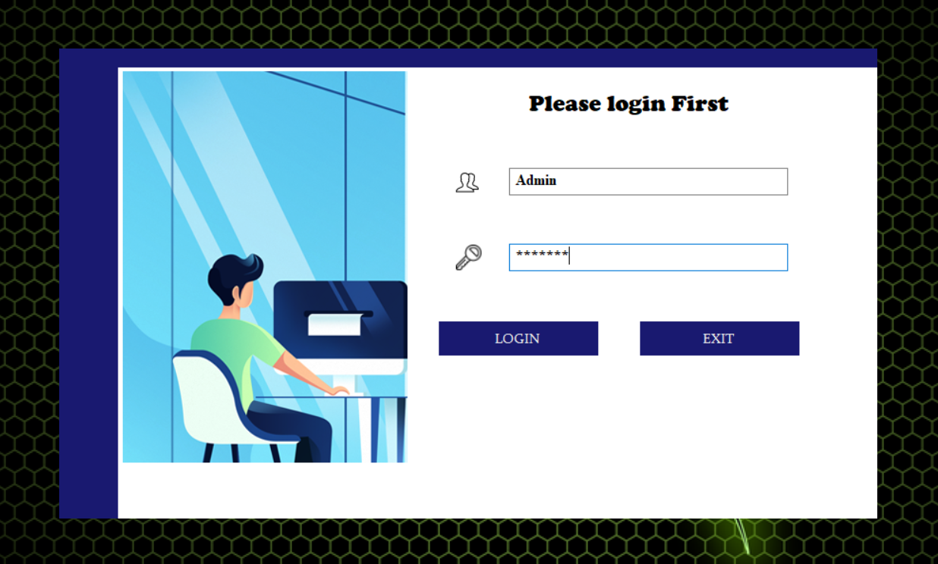

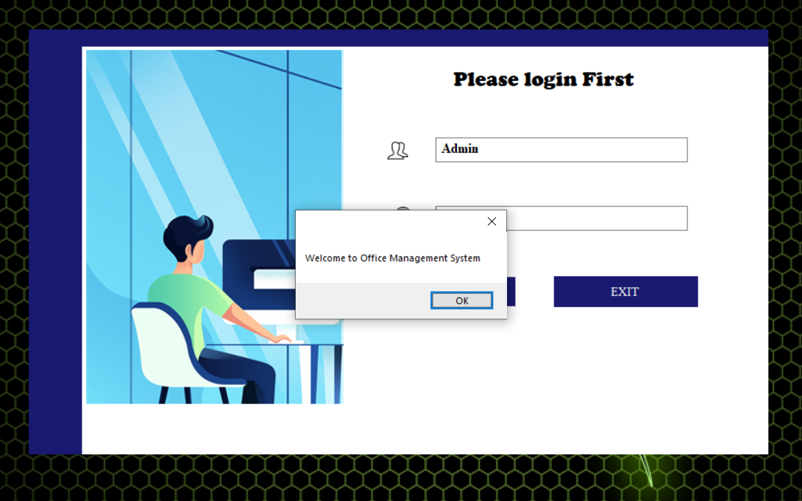

**Dash Board:-**

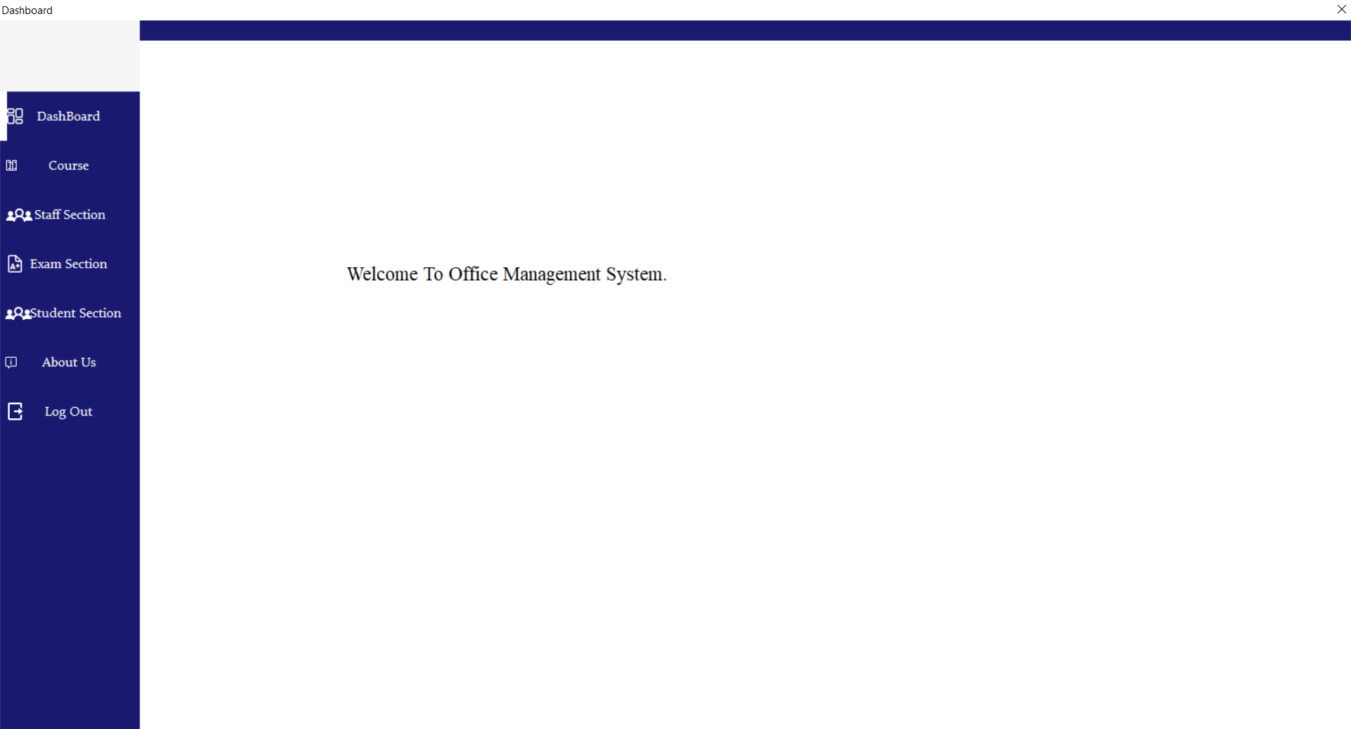

**Course :-**

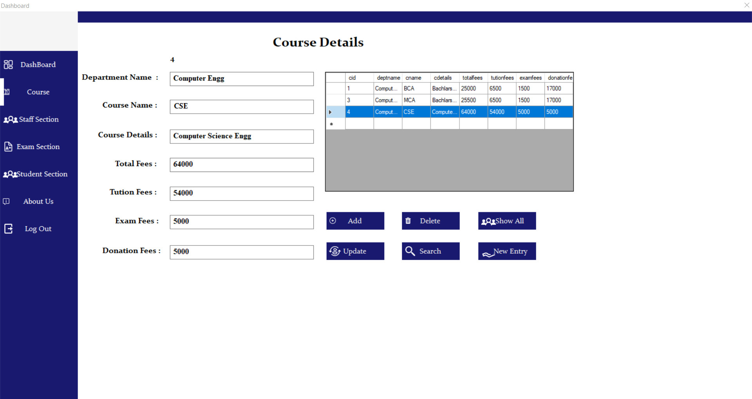

**Staff Selection:-** 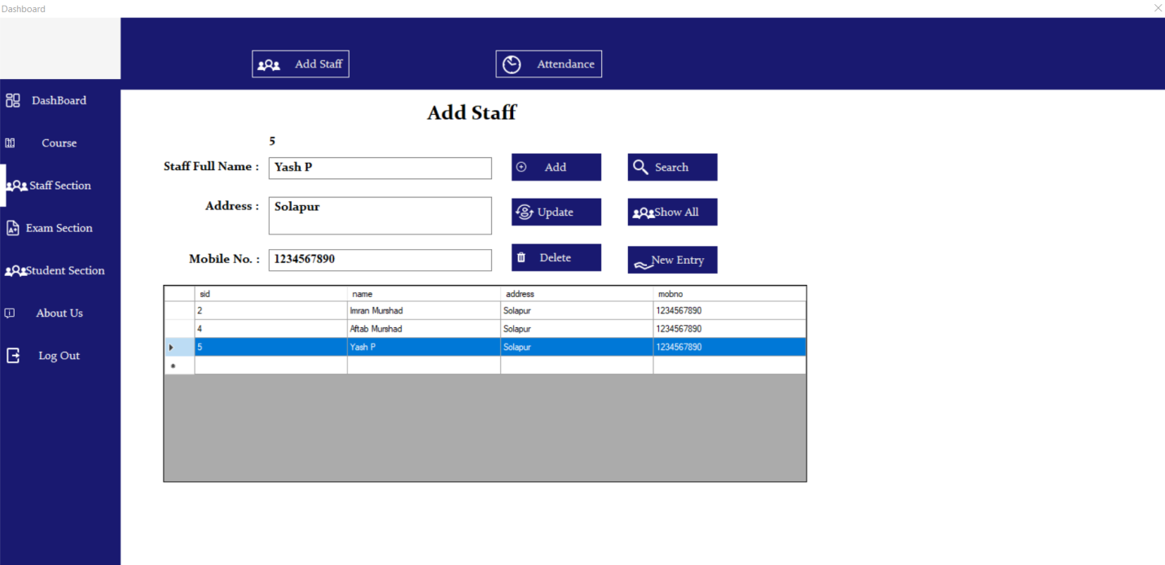

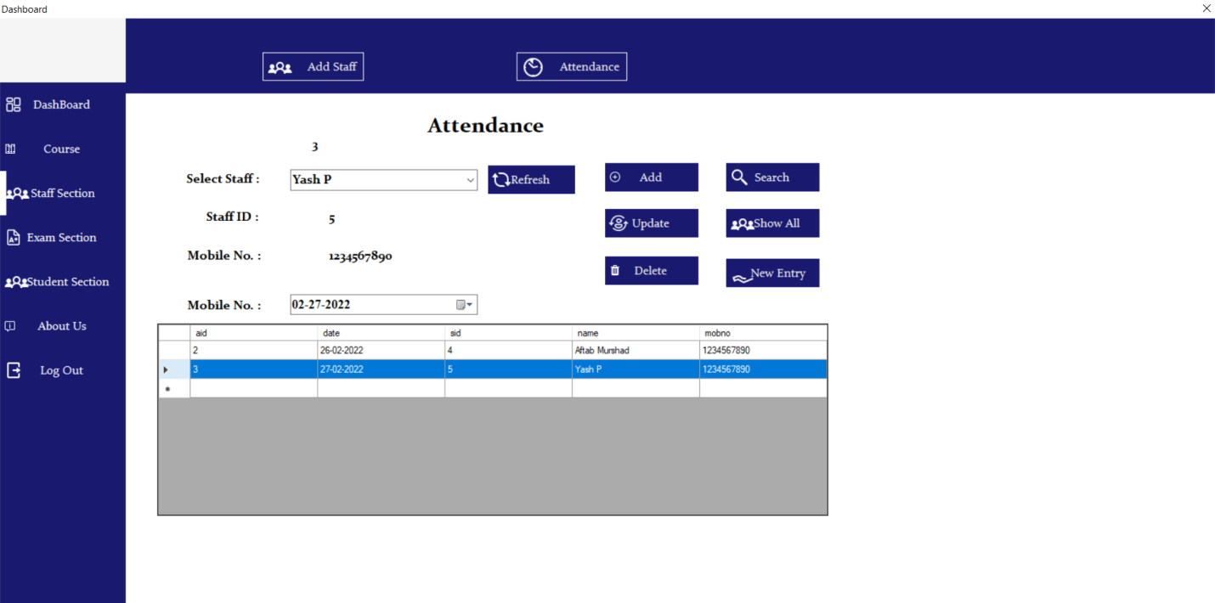

**Exam Slection:-**

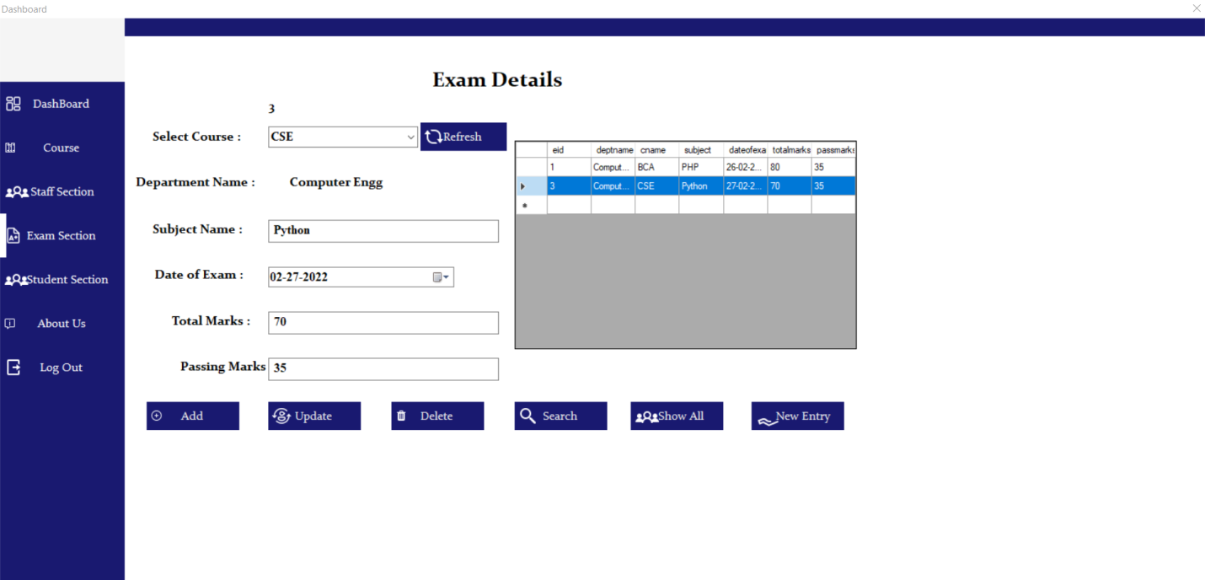

**Student Selection:-**

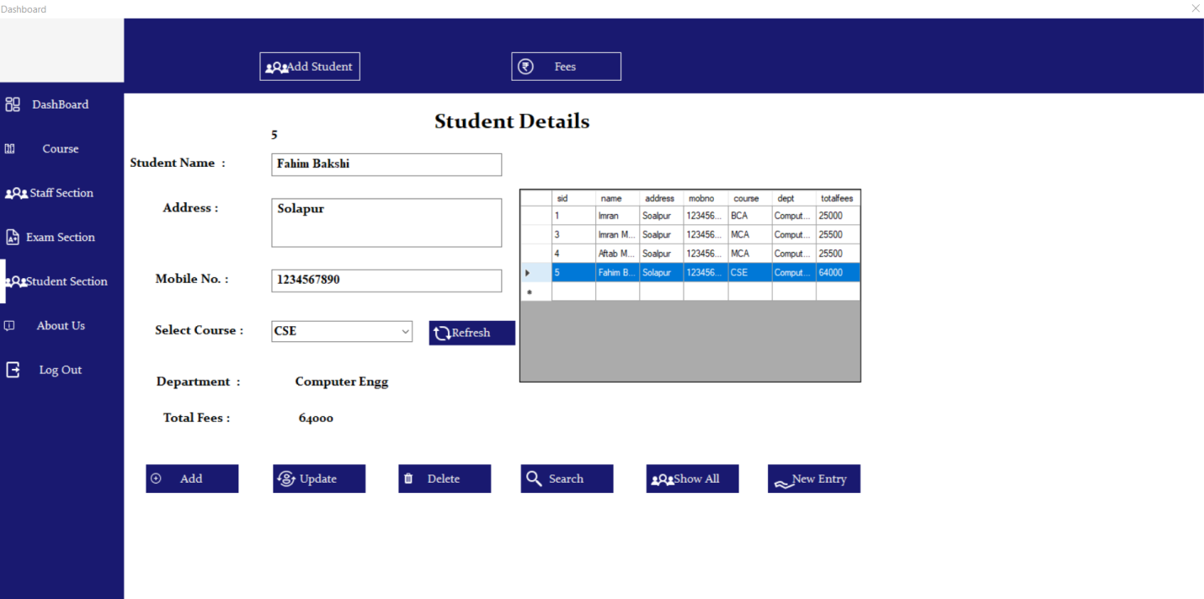

**Fess Details :-**

